**P250/1**

**GEOGRAPHY**

**(PHYSICAL GEOGRAPHY)**

**Paper 1**

**3 HOURS**

**ST JOHN’S HIGH SCHOOL KAWEMPE**

**UGANDA ADVANCED CERTIFICATE OF EDUCATION**

**S.5 – GEOGRAPHY PAPER 1**

**(PHYSICAL GEOGRAPHY)**

**TIME: 3 HOURS**

**INSTRUCTIONS TO CANDIDATES**

1. *This paper consists of* ***three*** *sections: A, B and C.*
2. *Answer* ***FOUR*** *questions.*
3. *Section A is compulsory.*
4. *At least* ***ONE*** *question should be answered from section B and* ***ONE*** *question from section C.*
5. *Credit will be given for use of relevant sketch maps, diagrams and specific examples studied in the field.*
6. *Any additional questions attempted will* ***not*** *be marked.*

**SECTION: A**

**COMPULSORY QUESTION: MAPWORK (25 MARKS**)

Study the East Africa ***1:50,000*(UGANDA**) **LUKAYA** map extract part of sheet **79/2** series **Y732 2-USD** edition and answer questions that follow.

(a) (i) State the grid reference of the Antiquity at Lukaya. (01 mark)

(ii) Name the man made feature found at grid reference 697957 (01 mark)

(b) (i) State the bearing of a church at Kankobe (878938) from the borehole at 736916 (03 marks)

(ii) Identify the Hemisphere in which Lukaya is found. (02 marks)

(iii) Identify the Location of Lukaya . (02 marks)

(c) Draw a sketch map of the portion between Northing 88 and 98, and Easting 80 and 88 and on it mark

and name; (10 marks)

(i) contour 3800

(ii) the seasonal swamp

(iii) lake victoria

(iv) Linear Settlement.

(d) (i) Describe the relief of the Area shown on the map. (03 marks)

(ii) Identify any three economic activities taking place in the area. (03 marks)

**Photographic interpretation**

**2. Study the photograph provided below and answer the questions which follow.**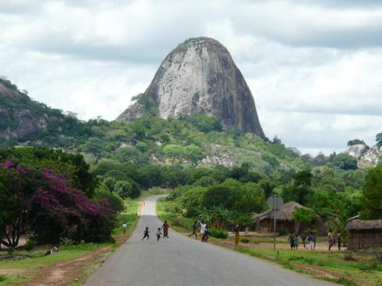

(a) Draw a landscape sketch of the photograph provided and on it mark and name:

1. One relief region
2. Two land use
3. Two vegetation types

(b) (i) Describe the processes responsible for the formation of the feature in the

Back ground.

1. Explain the relationship of relief and land use in the area.
2. What are the likely problems faced by the people in the photograph.

(c) Giving reasons, suggest an area in East Africa where the photograph could have been

Taken.

**SECTION B:**

**Attempt one question from this section.**

3. (a) Distinguish between a tilt block and a horst.

(b) Describe the processes responsible for the formation of horsts in East Africa.

5. Account for the formation of wave erosion landforms in East Africa.(25 marks)

4. To what extent does the subsidence theory account for coral reef formation in East Africa? *(25 marks)*

5. (a) Distinguish between vertical and lateral erosion. (06marks)

(b) Describe the formation of feature resulting from river erosion in East Africa. (19marks)

**SECTION C**

1. To what extent has altitude been responsible for distribution of natural forest vegetation in East Africa? (25 marks)
2. a) What is soil catena? (5 marks)

b) Examine the influence of the parent rock on the formation of soil types in

East Africa. (20 marks)